**Introduction**

For this assignment you must implement a version of Snake and Ladders game with slight advancements/ enhancements using Java. If you are not familiar with the original Snake and Ladders game, you can find a description here:

<https://en.wikipedia.org/wiki/Snakes_and_ladders>

There are no visual elements to the program. The entire program runs using a console window. All output will be text based and directed towards the console window.

**Full Description**

• You are required to implement an enhanced version of Snake and Ladders game. The game

will be played on a board containing 150 squares as shown in the figure below.

• You have to play the game using a 6-sided dice.

• You can decide on how you should generate numbers on each player’s turn.

• Make sure to print the value gained at each dice turn for all the players as well as the actions

and results that each player goes through within their turn.

o Ex:- **'<Player> has landed on <square name>'**

o Ex for an action:- **‘<Player> has landed on <square name> with a <action>, moving to the new position <square name> ’**

**Game Rules:**

1. There should be only 3 players for this game.
2. A player can start the game only if he/she gets 1 or 6 in their first turn.
3. If the player has entered the 149th square, then he/she must get another 1 to win the game. Nothing more.
4. You can then start the game and the first one to reach 150th square will win the game. However, there will be pre-set special squares which will consist of the following actions:

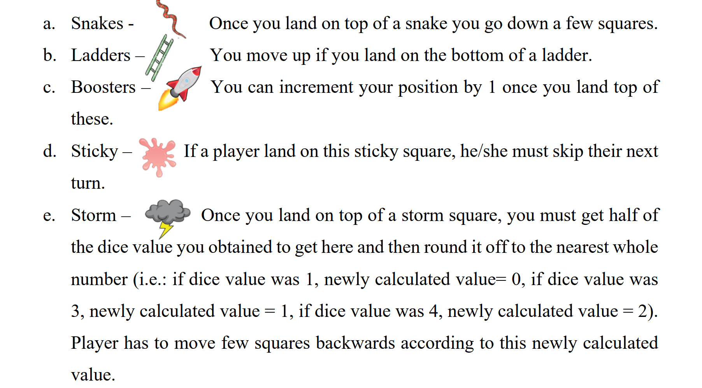

Sample Board

